

|  |  |  |  |  |  |  |  |  |
| --- | --- | --- | --- | --- | --- | --- | --- | --- |
|  | | | | | | | | |
|  | | Back-End Dev. Proj. Report | | | | |  | |
|  |  | | | | | | |  |
|  | | | |  |  | | | |
|  | | | | Yibo Zhu |  | | | |
|  | | | | 11/25/2020—Back-end Web Development—Instructor: Kelvin Gao |  | | | |
|  | | |  | | |  | | |



|  |  |  |  |  |  |  |  |  |
| --- | --- | --- | --- | --- | --- | --- | --- | --- |
|  |  | | |  |  | | |  |
|  | INSTRUCTIONS | | | | | | |  |
|  |  | | |  |  | | |  |
|  |  | |  | | |  | |  |
|  |  |  | You need to submit this report with the (images of) tables for the database (Project Description Section 2.2) and all source codes and resources. You can also host your website on AWS and submit the URL. | | |  |  |  |
|  | | | | |
|  |  |  |  |
|  |  |



|  |  |  |  |  |  |  |
| --- | --- | --- | --- | --- | --- | --- |
|  | |  |  |  |  | |
|  | | THE PROCESS | | |  | |
|  | |  |  |  |  | |
|  | Introduction This project begins from the login page. After user login or signing up, the home page will show, which has two options “course info” and “personal info”. After user selection, user can modify his courses, see the courses enrolled, search the course by course id, name and instructor, modify his personal info and so on.  I build 3 tables for this project, students, courses, and student_courses. Student_couses is a table which collects studentID(FK) and coursed(FK) to show the student enrolled courses. | | | | |  |
|  | Implementation Student part  Module 1: Sign in  (Bonus) Model: model/student_db.php; View: Sign_in_manager/sign_in.php; Controller: index.php  Module 2: register  Model: model/student_db.php, model/validate.php; View: sign_up_manager/sign_up.php, sign_up_manager/sign_up_result.php; Controller: sign_up_manager/index.php  Module 3: course info  Model: model/course_db.php, model/student_db.php, model/student_courses_db.php; View: course_manager/show_course.php; Controller: course_manager/index.php  Module 4: personal info  Model: model/student_db.php, model/student_courses_db.php; View: personalInfo_manager/profile.php, personalInfo_manager/show_enrolled_courses.php; Controller: personalInfo_manager/index.php | | | | |  |

1. PHP and MySQL

Yes

2. HTML form processing

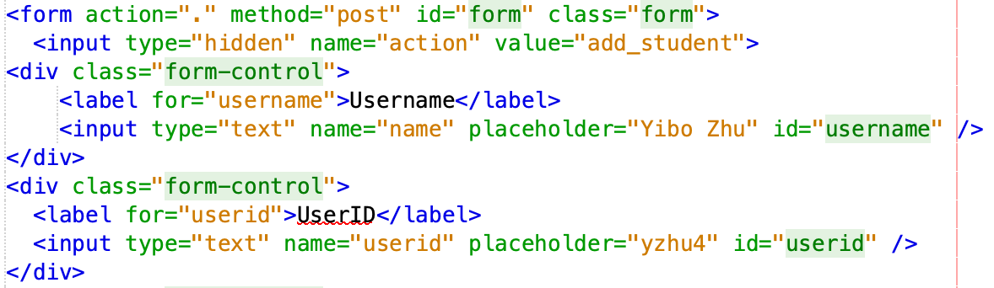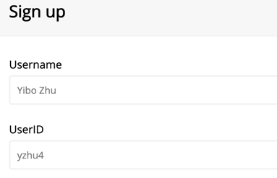

3. Using if-else in index.php page

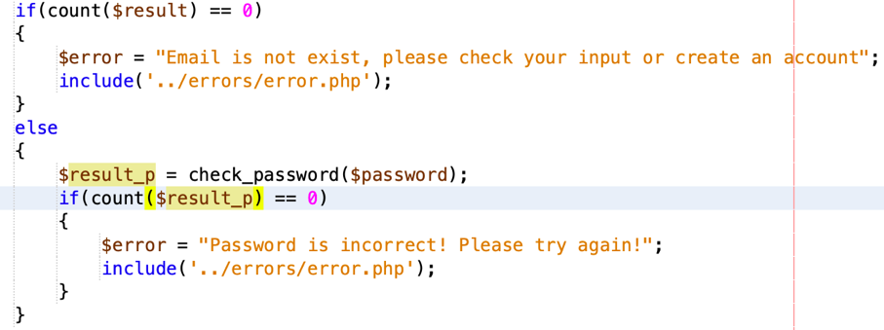

Switch case

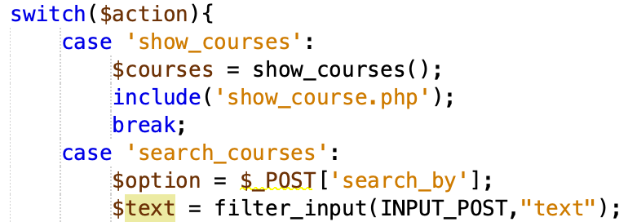

Loop

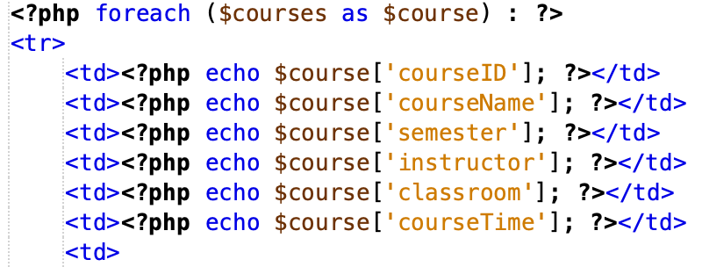

4. Using string processing in Sign Up page:

I let user input full name. In the index.php page, I split the string to first name and last name.

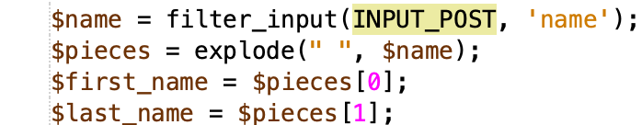

5. Array

In validate.php, use array fields to store all the error message then show in the sign_up_result page

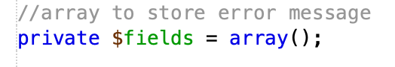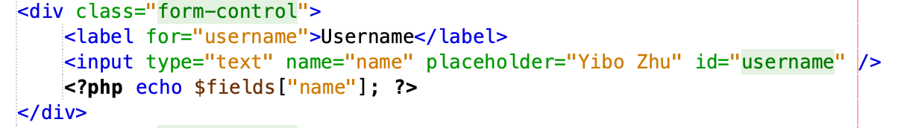



6. Sessions:

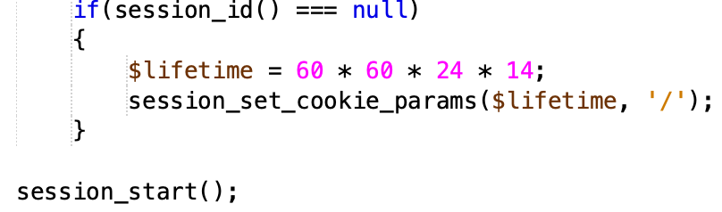

7. Using functions inside database pages:

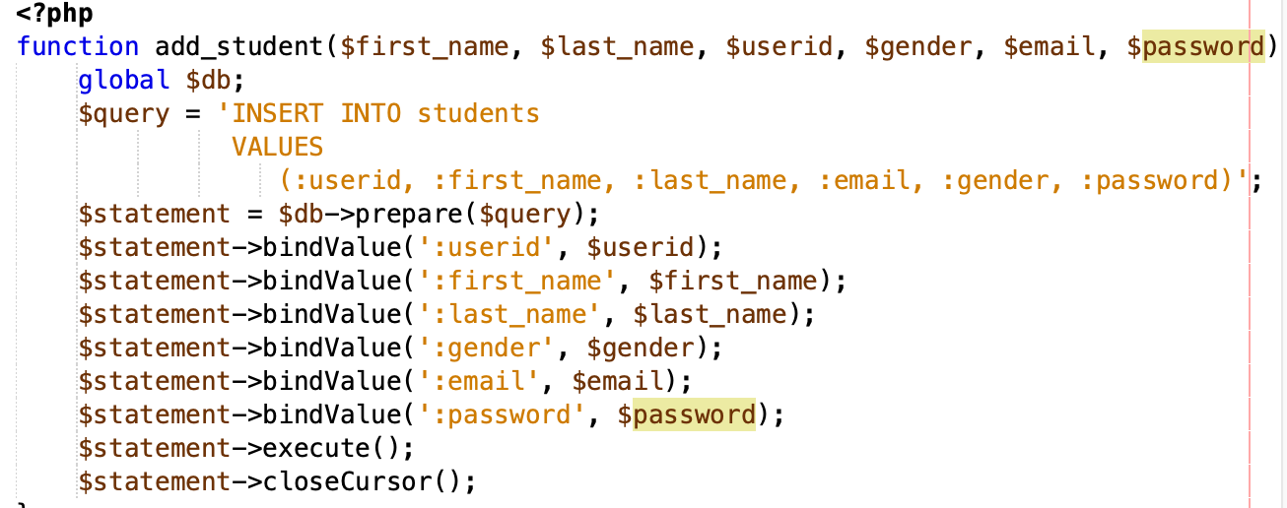

Validate.php check functions

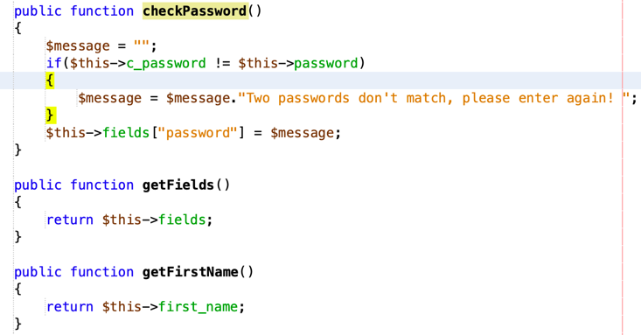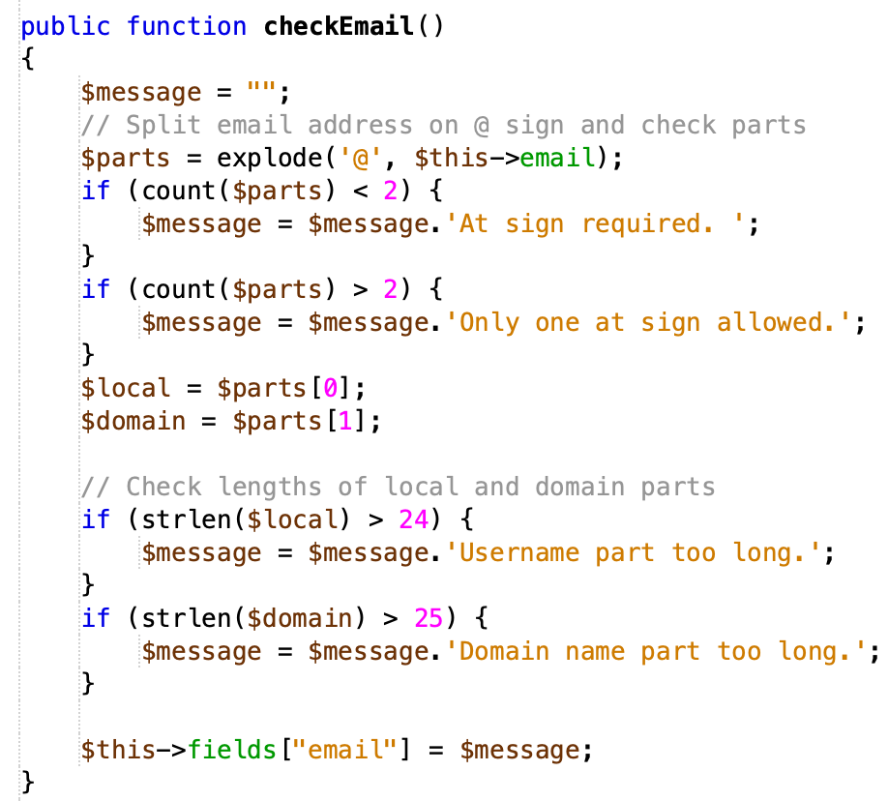

8. Object

In validate.php, built a class to validate all the inputs

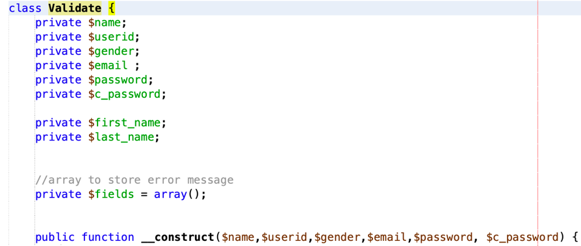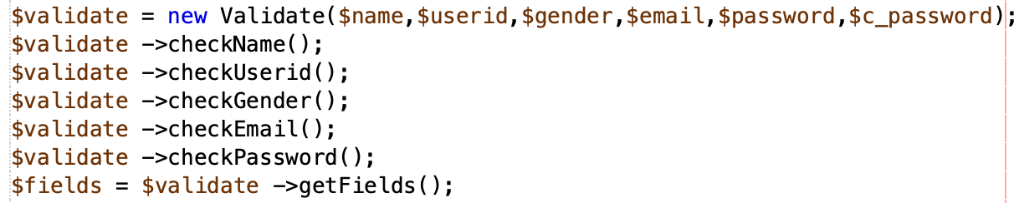



Database:

courses

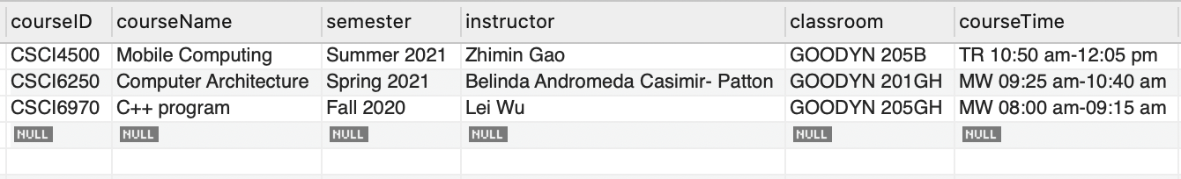

student_courses

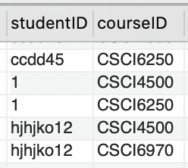

students

